**Document Change Control**

|  |  |  |  |
| --- | --- | --- | --- |
| **Version** | **Date** | **Authors** | **Summary of Changes** |
| 1 | 14/04/2018 | Keagan Foster | Initial Draft |
| 2 | 22/10/2018 | Tingcong Jimmy Li | Removed unnecessary instructions from the draft, simplified the instructions. |
| 2.1 | 27/10/2018 | Tingcong Jimmy Li | Added images to support instruction |

**User Manual**

**V 2.1**

**Installation**

1. Install Node, server(laptop) and glasses must be connected to the same wifi  
2. Download source code  
3. Install dependencies via *$npm install*

**Usage**   
1. Start server  
 1. on laptop: cd to the source directory, then $npm start, port is currently set to 5000  
 2. on laptop: browse to localhost:5000/admin for the admin panel  
 3. on glasses: browse to <*server ip*><*port:5000*>.   
2. Streaming mode  
 1. Streaming starts automatically, the first pair of glasses to connect to the server is automatically assigned the INSTRUCTOR role, second pair is OPERATOR  
3. Sketching mode  
 1. Access the admin panel in 4.2, click “switch to sketching”, both user’s video feed will freeze (a snapshot). Finger tracking/sketching processing will proceed from instructor’s camera/hand

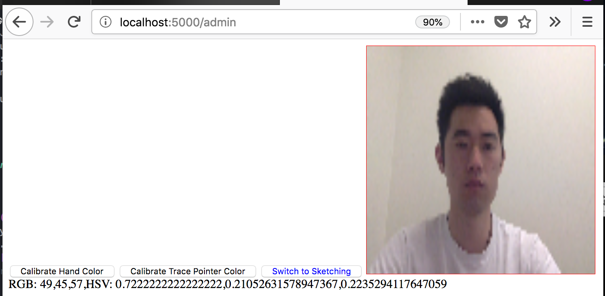

4. Calibration  
 1. Color calibration is accessible on the admin panel in step 1.2.  
 2. Calibrate for streaming: click “calibrate for streaming”, a snapshot will be taken from the instructor’s camera This will only work if users are currently in streaming mode  
 3. Calibrate for sketching: click “calibrate for sketching”, a snapshot will be taken from the instructor’s camera This will only work if users are currently in sketching mode  
 4. Mouse over and click on the desired color in the snapshot to calibrate  
  
*Note: Firefox should be used to browse on the smart glasses instead of the default browser. There is no keyboard on the smart glasses, we have set browser homepage to the server ip for development purposes. Another app (autostart) is used to launch Firefox 10 seconds after boot(wait for wifi) due to having no access to root.   
We have disabled Firefox mediadevice permission in about:config to eliminate permission dialogs. A bluetooth keyboard can be used to change the homepage. The QR code scanner can also be used to scan generated web address for firefox to open, in our case, the server’s ip address/port. It can also be used to connect to wifi.*